API Testing for Lambdas

Create an S3 buckets to add external packages dependencies required by Lambdas like pymongo, certify etc.

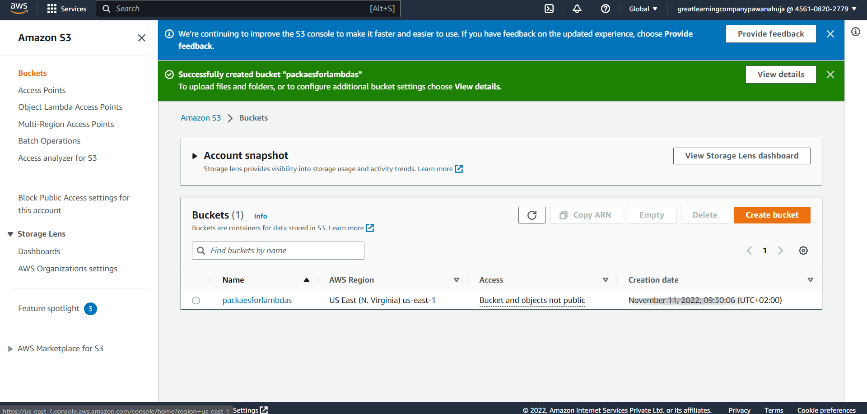

Copy zip of external dependencies to created S3 bucket

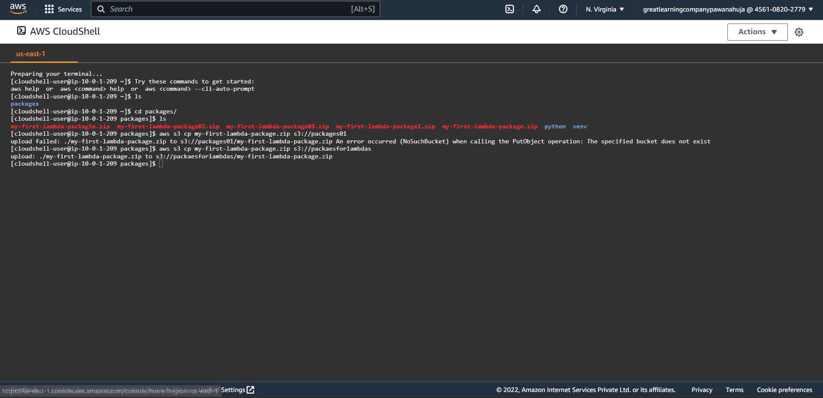

**S3 bucket with packages**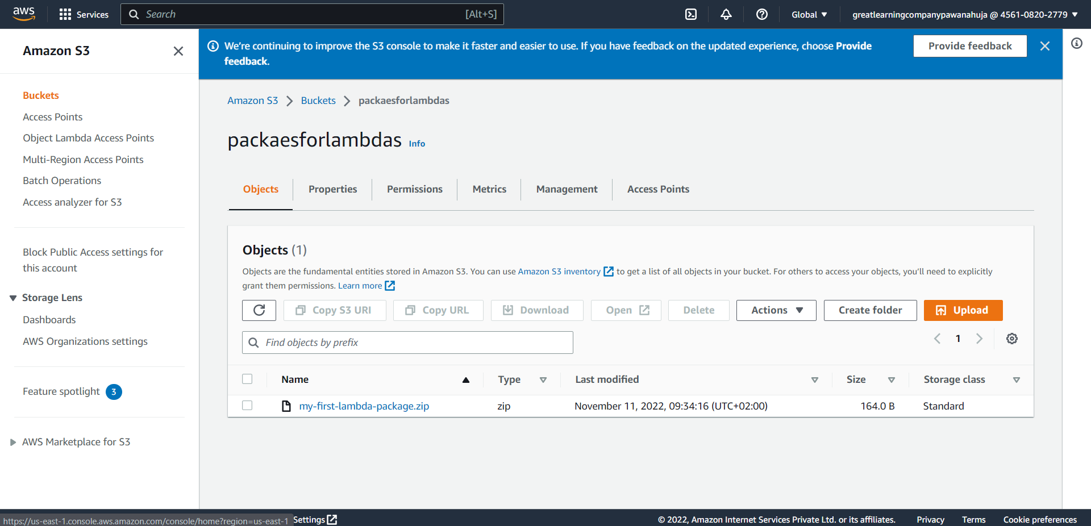

**IAM role for Lambdas**

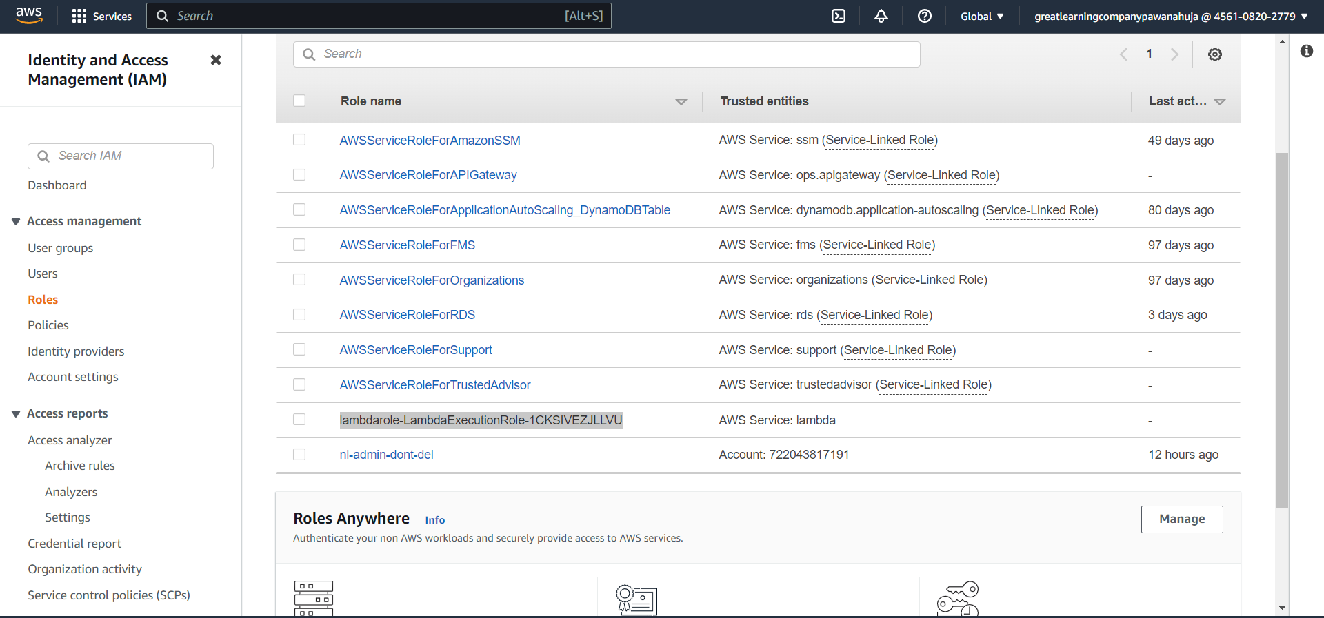

**3 Lambdas**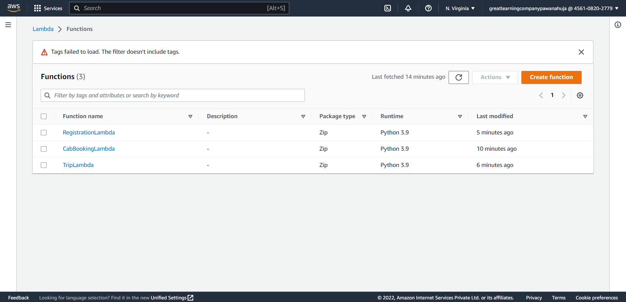

**API Gateway**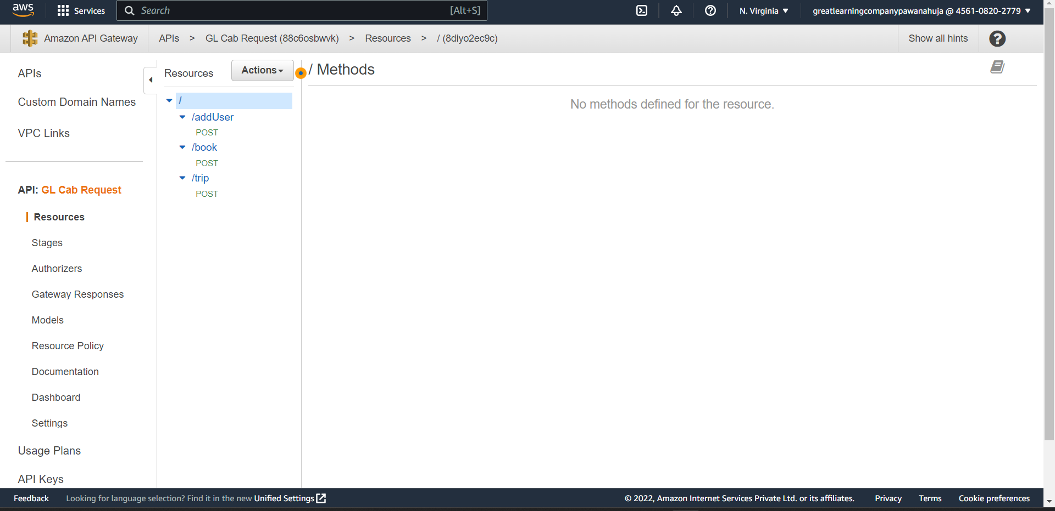

**Deployed API**

<https://88c6osbwvk.execute-api.us-east-1.amazonaws.com/cabme>

**Postman testing results**

**Adding user** 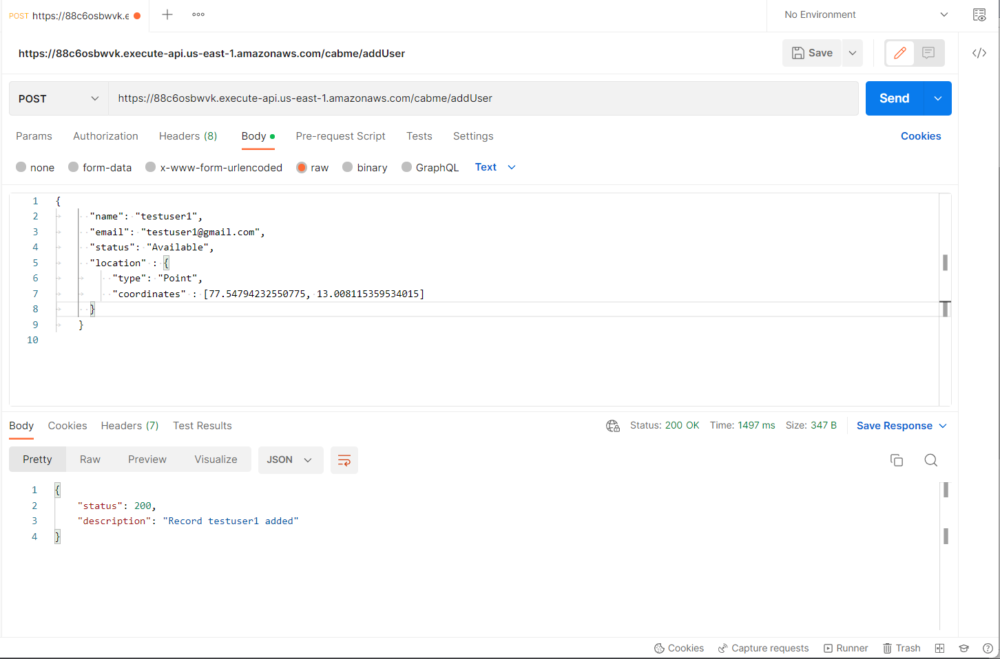

**Added user in Mongo**

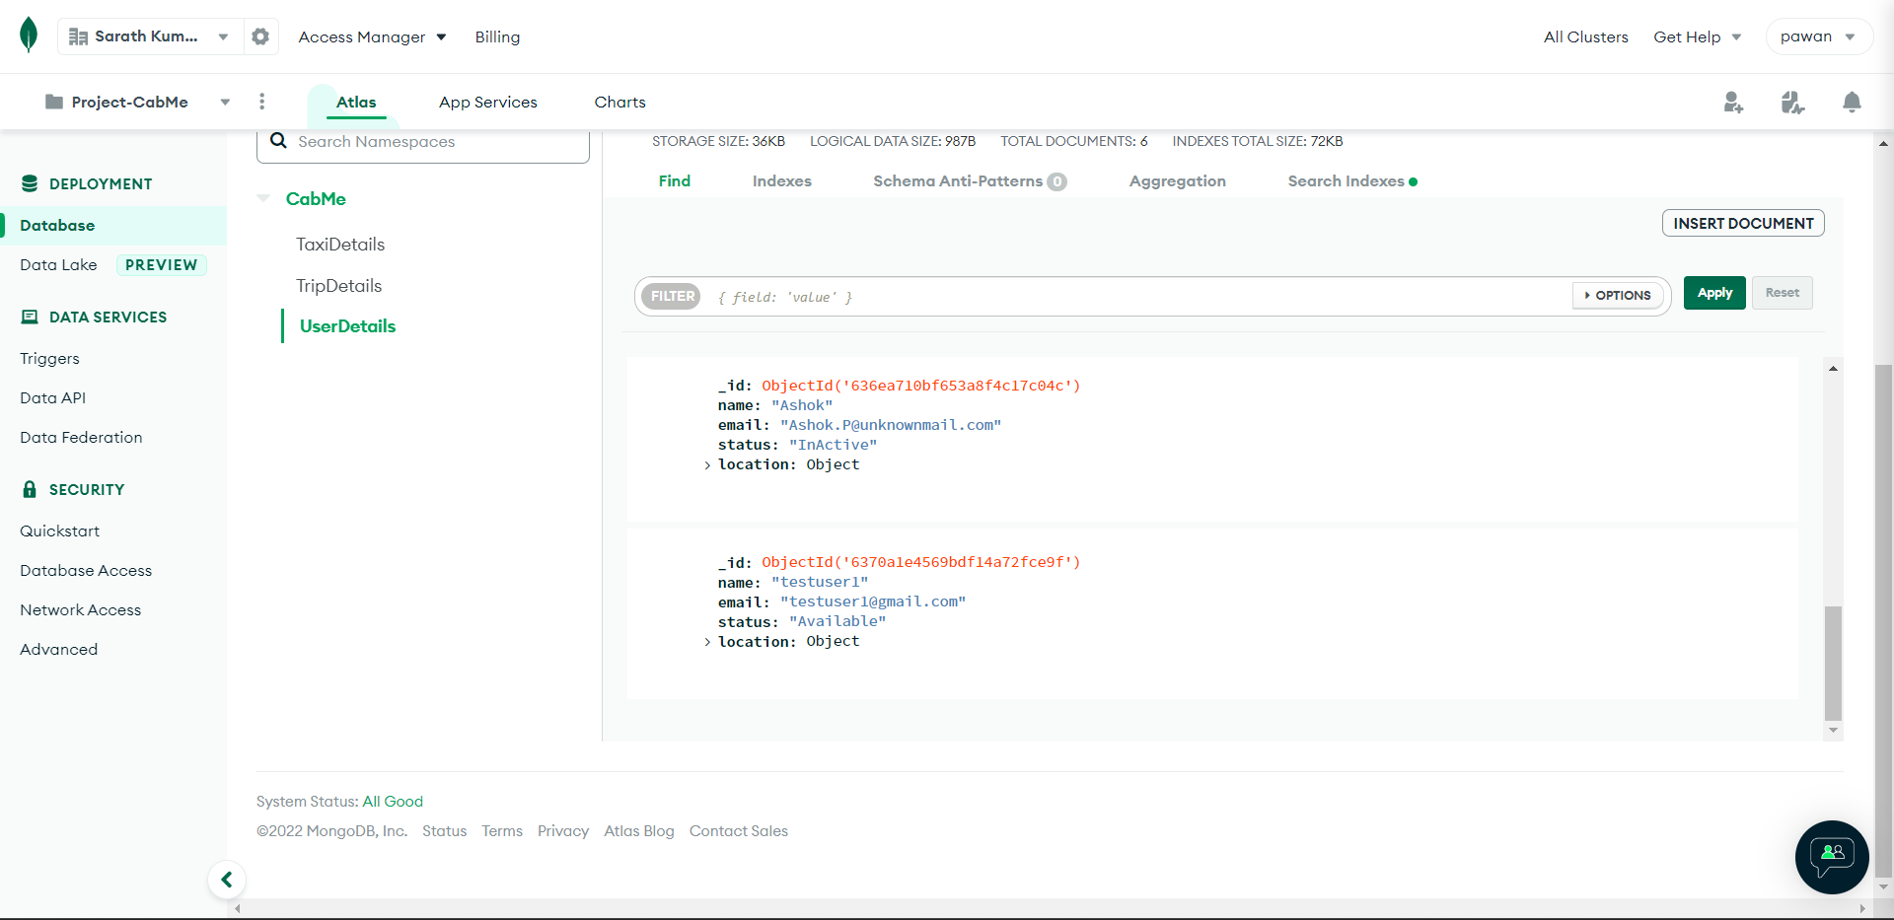

**Validation when adding user with same email**

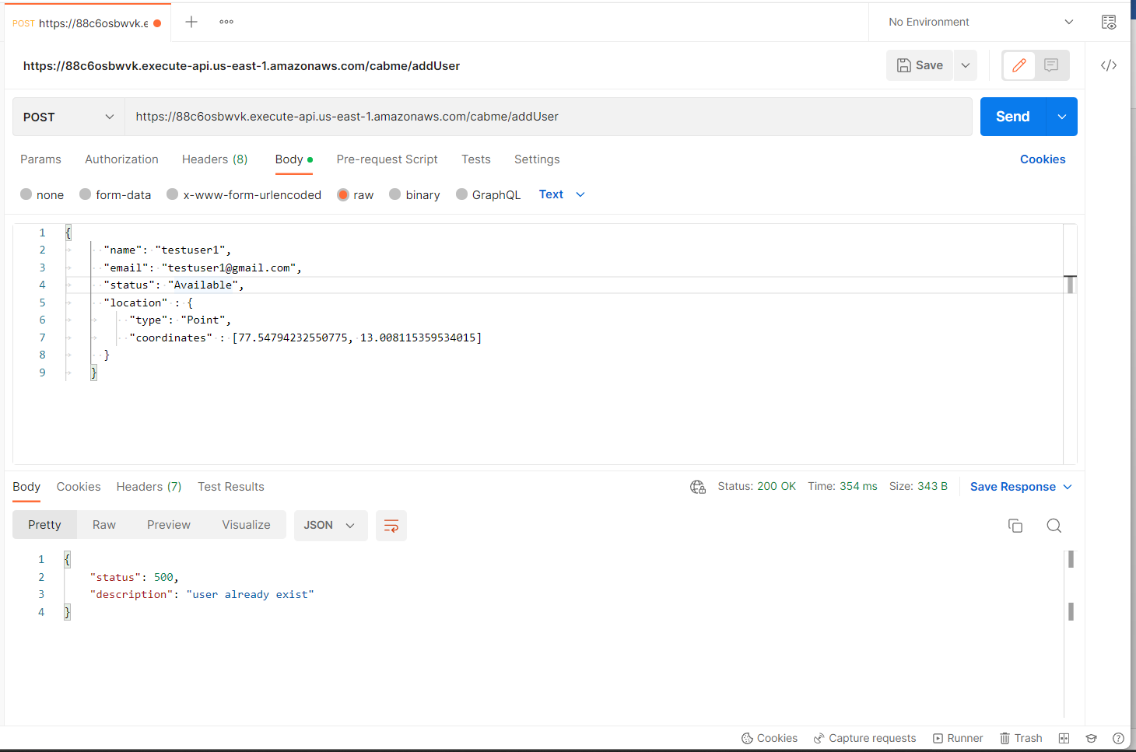

**Adding Taxi**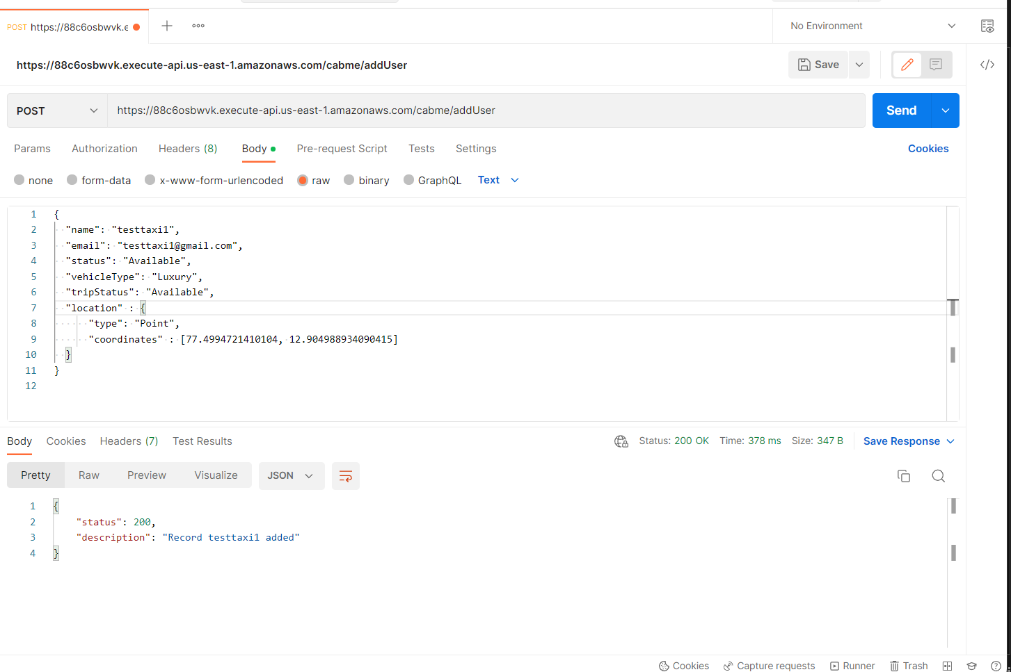

**Added Taxi**

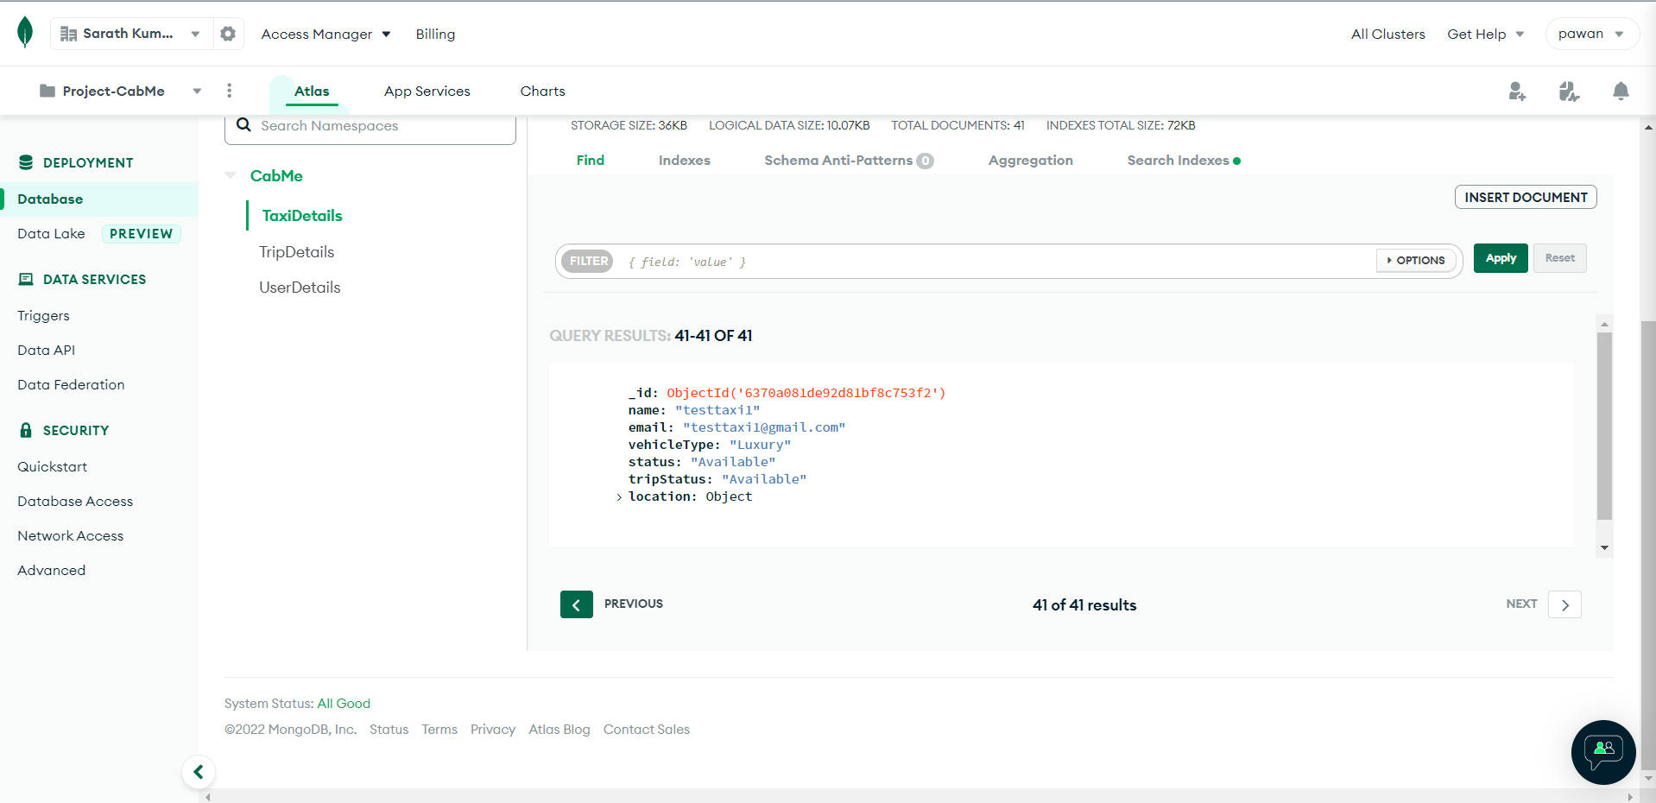

**Validation when adding taxi with same email**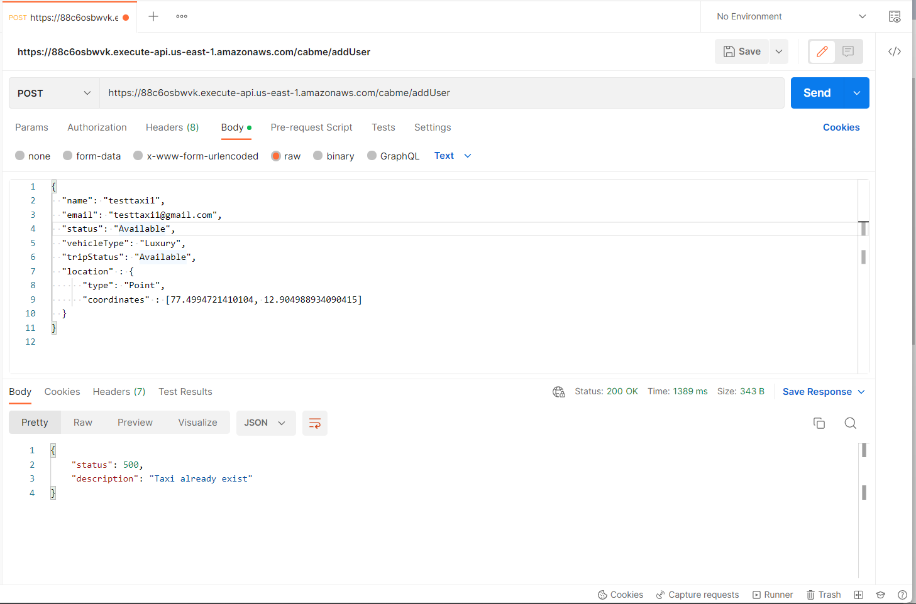

**Booking cab for user** [**testuser1@gmail.com**](mailto:testuser1@gmail.com)

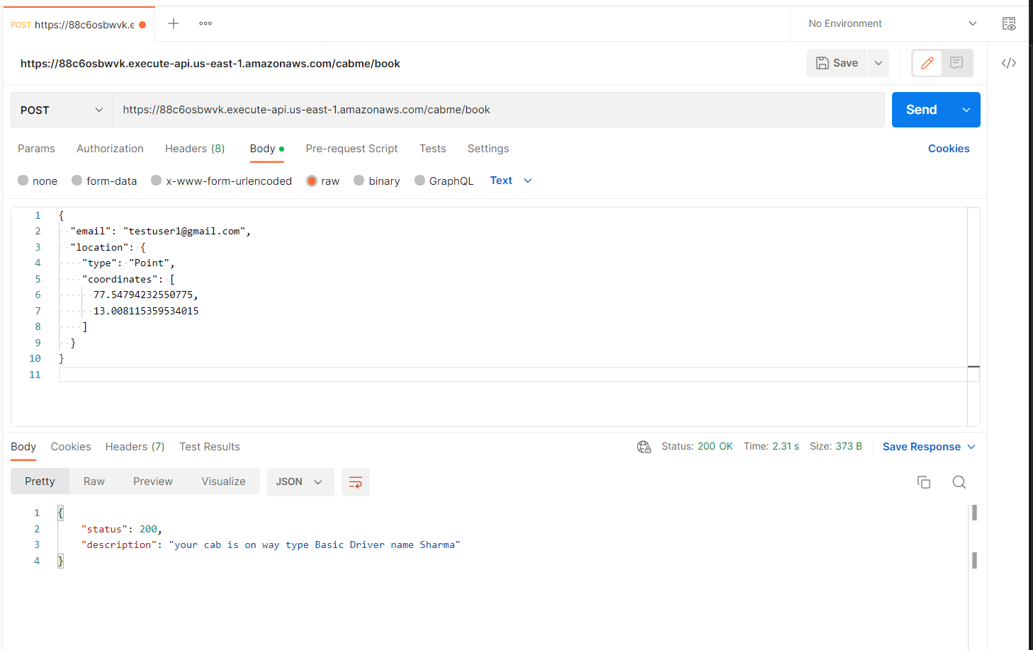

**Taxi status updated to Unavailable**

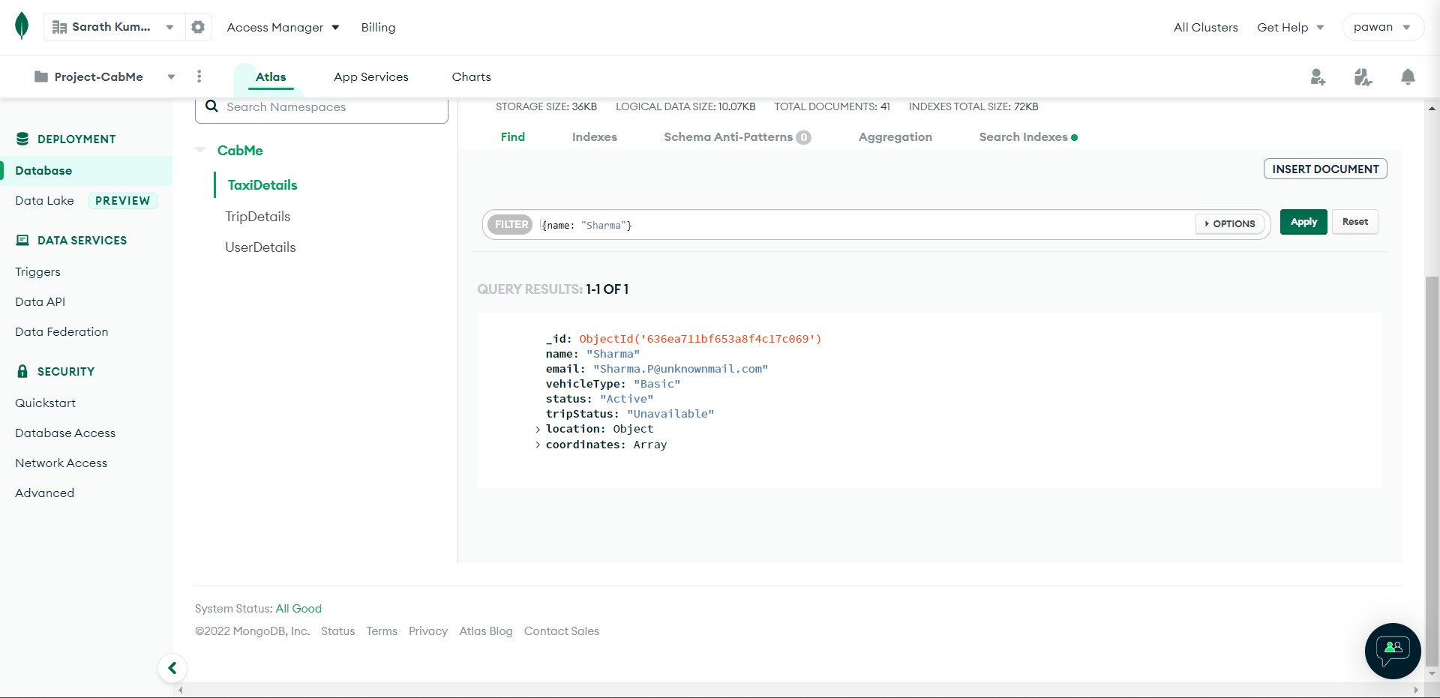

**Trip created for the user-taxi**

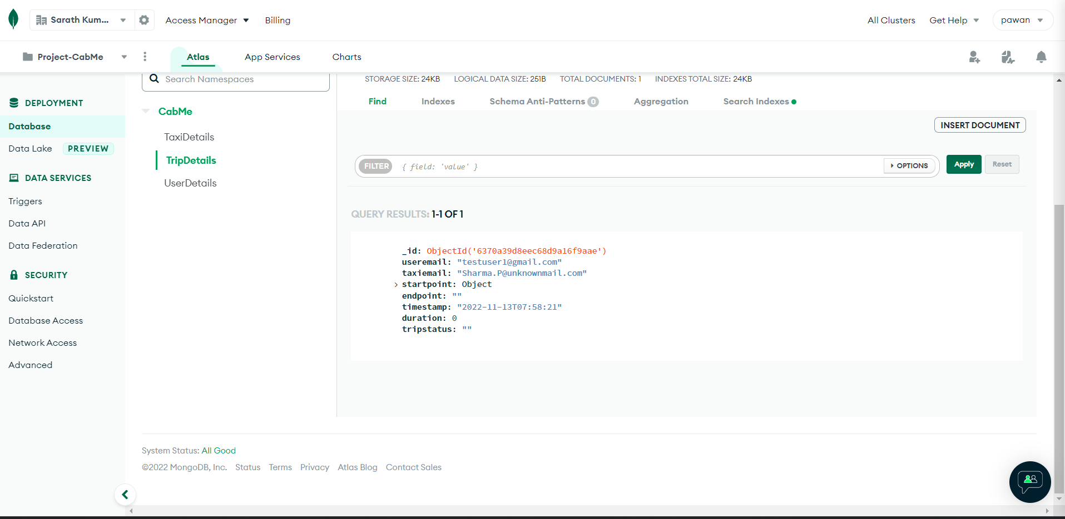

**Start trip**

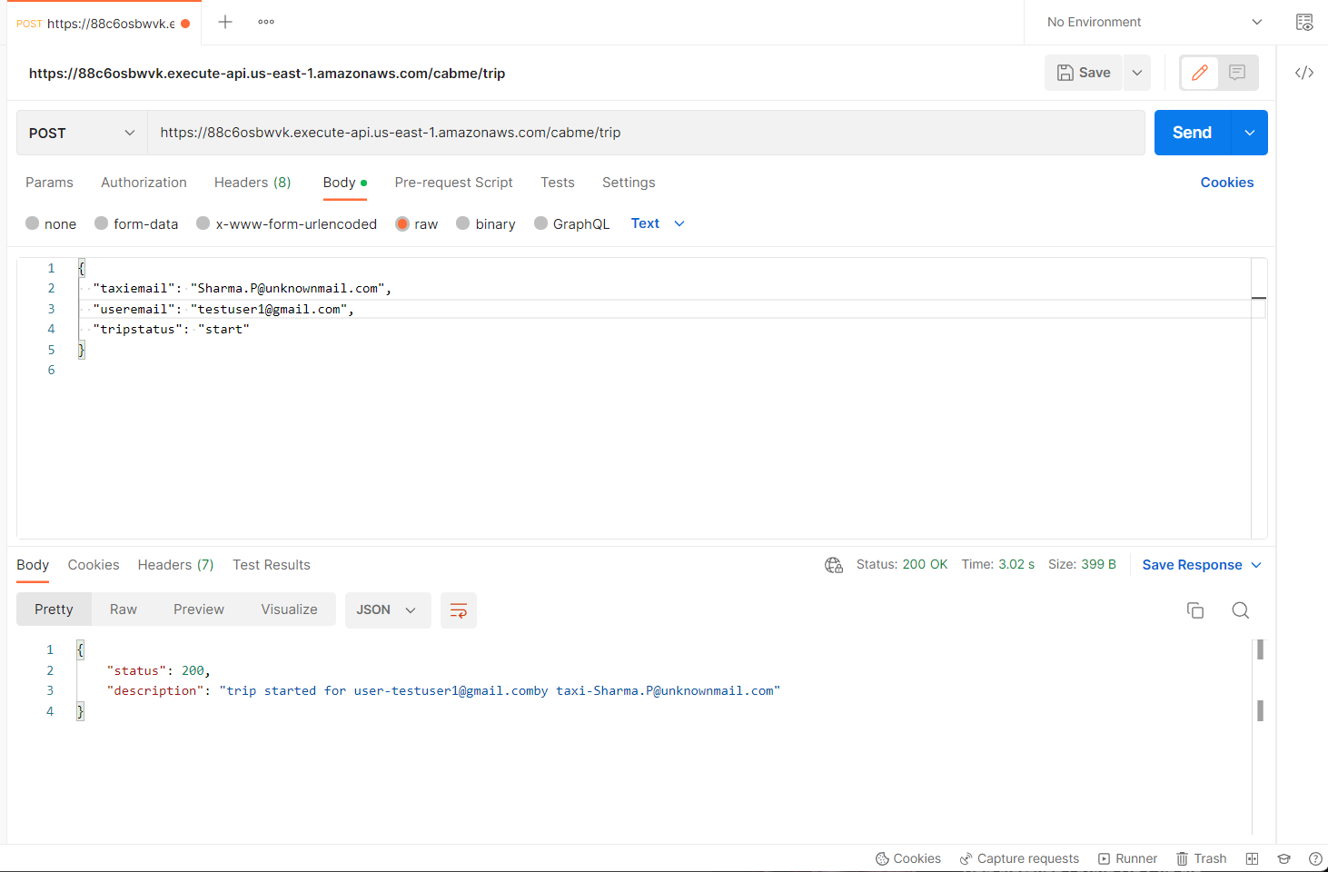

**Trip status after start of trip**

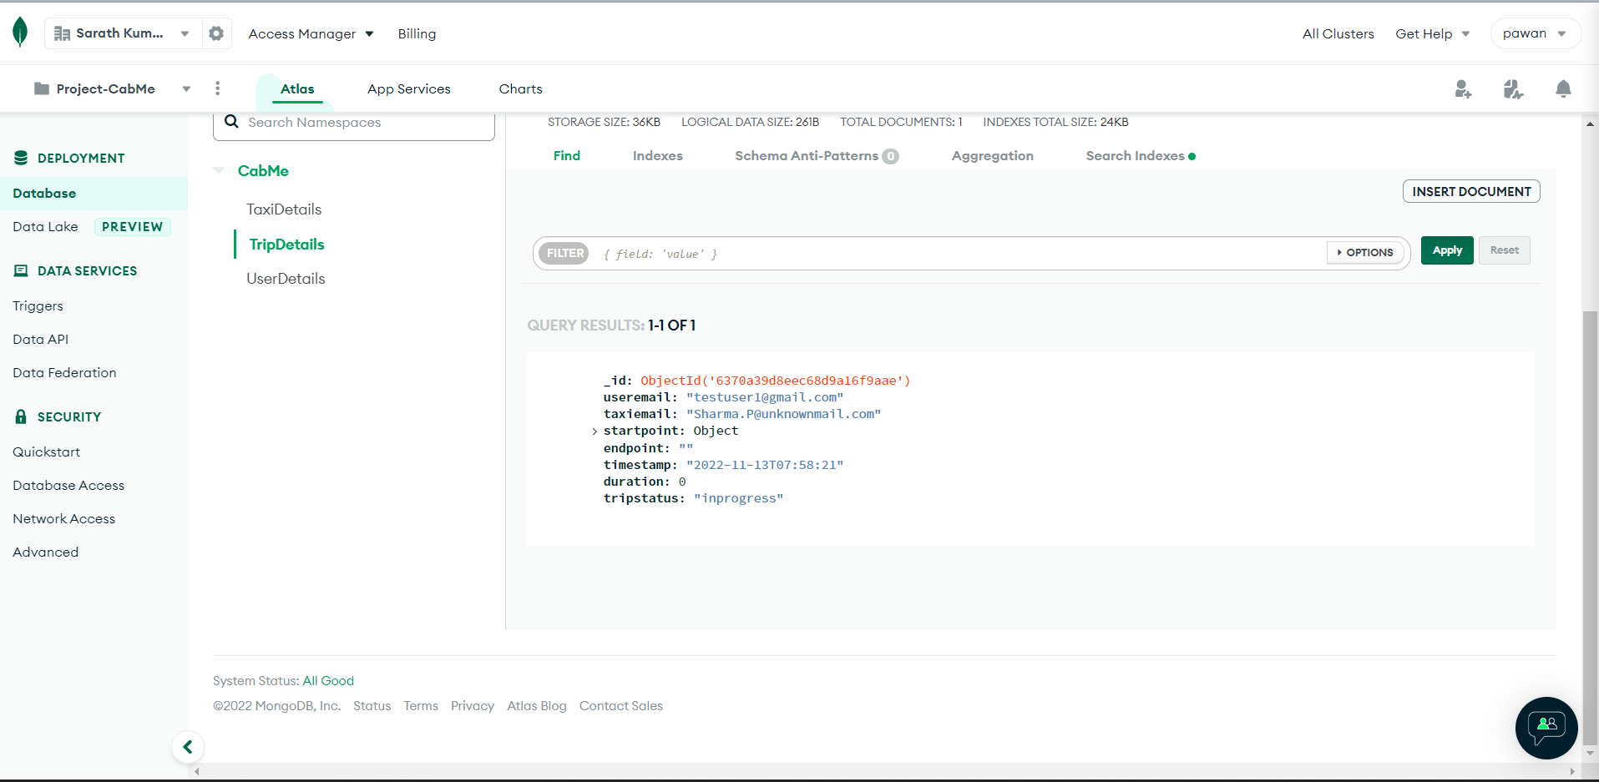

**End Trip**

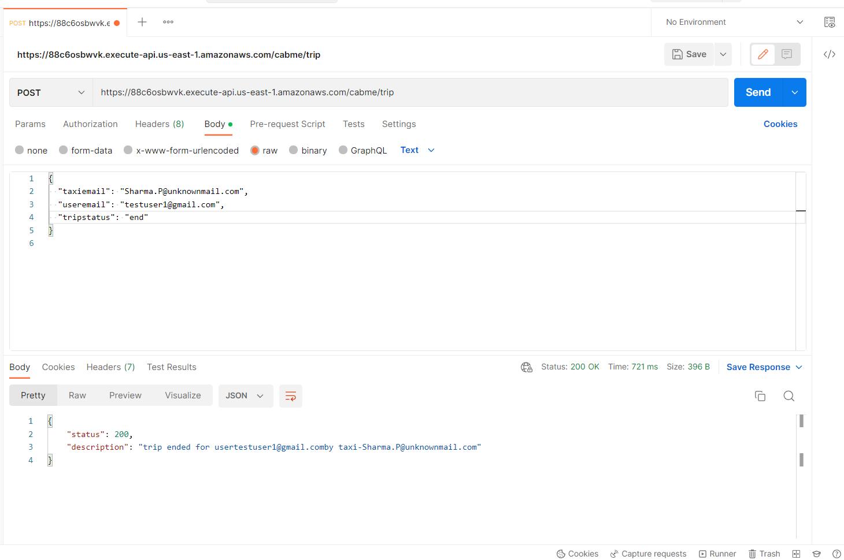

**Trip status after end trip**

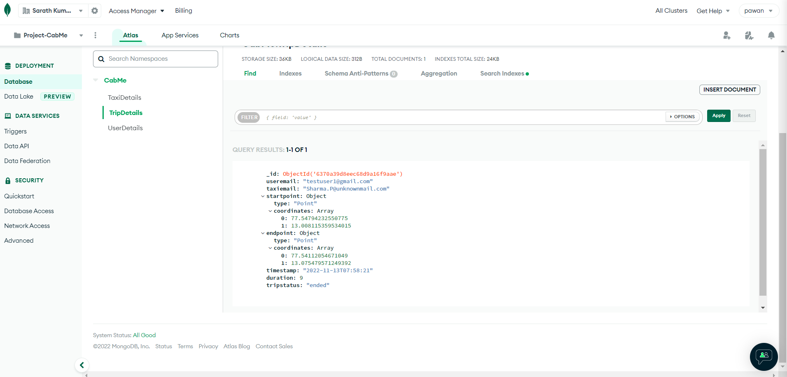

**Driver becomes available after trip ends**

